**OUTREACH NOTICE**

**Region 4**

**Humboldt-Toiyabe National Forest**

**Bridgeport Ranger District**

**GS-0486-9/11 Wildlife Biologist**

The Bridgeport Ranger District is currently outreaching for one permanent full-time GS-0486-9/11 Wildlife Biologist position. The duty station is Bridgeport, CA. Depending on the outreach response, referral lists will be considered in both the Merit and Demo categories. All interested applicants should submit the attached outreach survey form so they can be notified of the vacancy announcement number and closing date when it becomes available.

**Position Information**

The successful applicant will be responsible for management of the wildlife and fisheries program on the 1.2 million acre Bridgeport Ranger District. The Endangered Sierra Nevada Bighorn Sheep, Threatened Lahontan Cutthroat Trout, Sierra Nevada red fox and the Bi-State sage grouse population can all be found on the District.

Duties include participating on NEPA interdisciplinary teams in support of projects involving fuels, range, minerals, recreation, special uses and other forest programs, including wildlife. The incumbent will develop biological assessments in compliance with the Endangered Species Act, participate in planning and implementing wildlife surveys, monitoring, and habitat improvement projects. Collaboration with other federal and state agencies in the management of wildlife habitat and species is a key component of this position. The specialist will seek to develop partnerships with non-governmental organizations to manage wildlife habitat. Attendance at public and agency meetings on a variety of technical and professional topics will be required.

**About the Bridgeport Ranger District and Humboldt-Toiyabe National Forest**

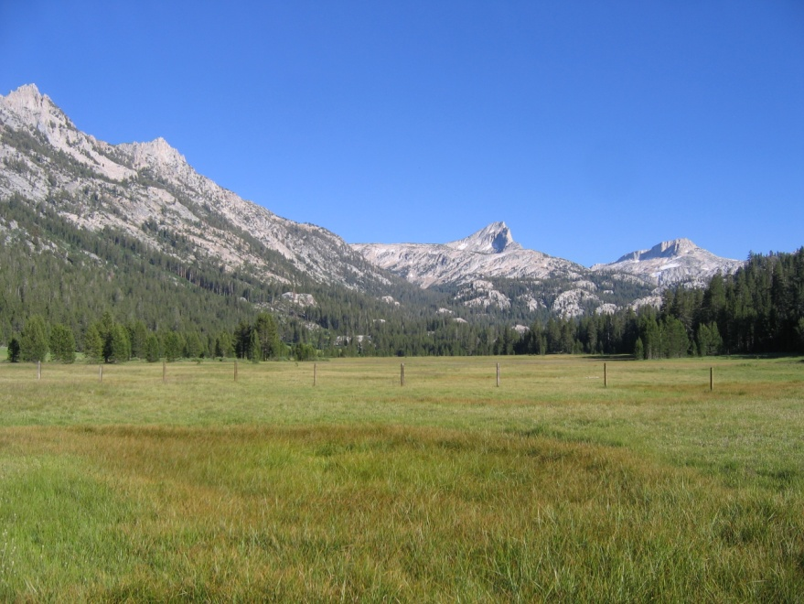The Humboldt-Toiyabe National Forest consists of 6.3 million acres and includes ten ranger districts. The Bridgeport Ranger District is located on the west side of the H-T; flanked on the west by the dramatic Sierra Nevada and falling away eastward to the Great Basin Desert. The Bridgeport District encompasses 1.2 million acres and spans 5 mountain ranges. Two-thirds of the district is in Nevada, one-third is in California. The District borders Yosemite National Park and several wilderness areas. Vegetation ranges from high alpine plant communities to salt desert flats.

The District has a robust program of work that covers range, fire and fuels, recreation, wildlife, fisheries, watershed, noxious weeds, minerals and special uses. There are about 30 permanent employees and the District typically hires additional seasonal employees. The District is also home to the US Marine Corps Mountain Warfare Training Center.

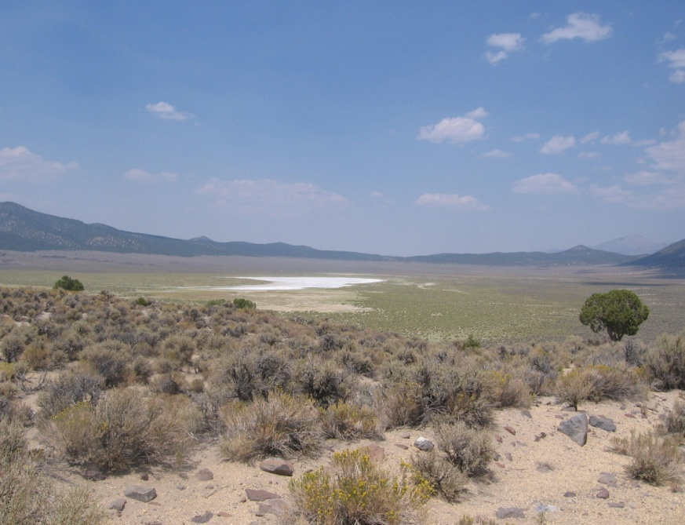**Bridgeport Community Information**

The Ranger Station is located in Bridgeport, CA, a town of about 800 year-round residents, nestled at the base of the Sierra Nevada. In the summer, the area swells with tourists coming to enjoy the scenic beauty and outstanding fishing opportunities. Bridgeport is about 45 minutes from Yosemite National Park, 1 1/2 hours from Lake Tahoe, and 2 1/2 hours from Reno, NV.

Government housing may be available with this opportunity. Housing in Bridgeport is limited. Rentals range from $600 to $1000+ per month. A typical 3 bed/2 bath single family home in Bridgeport costs anywhere from $250,000-$350,000+.

Bridgeport has a K-8 elementary school. High schools are located in Lee Vining, CA and Coleville, CA. Churches representing several denominations can be found within the local commuting area. Bridgeport has a small clinic and ambulance and Life-Flight services. Hospitals are located in Gardnerville, NV and Mammoth Lakes, CA. Bridgeport has a small grocery store and several restaurants/bars.

Annual precipitation in Bridgeport averages 9 inches/year. Total annual snowfall averages 50 inches with most occurring from December to February. Summer highs in Bridgeport rarely reach 90 degrees (F) or above. In winter, low temperatures can reach 30 below zero.

**Contact**

If you are interested in the Bridgeport Wildlife Biologist position, contact Mike Crawley, District Ranger, at 760-932-5801 or [mcrawley@fs.fed.us](mailto:rixeyjenkins@fs.fed.us).

**OUTREACH RESPONSE FORM**

Bridgeport Ranger District

PERSONAL INFORMATION

Name: Date:

Address:

Phone: Email address:

Brief Description of Qualifying Experience:

**Thank you for your interest!**

Please return the Outreach form to Mike Crawley, District Ranger, [mcrawley@fs.fed.us](mailto:rixeyjenkins@fs.fed.us).